OPERATING SYSTEM SECURITY AND FUNDAMENTALS(LINUX AND WINDOWS)
Linux virtual machine using VirtualBox or use Windows security settings.

Linux Virtual Machine (VirtualBox)
Best if you want Linux or strong isolation
Pros
- Full Linux OS
- Strong separation from Windows
- Great for learning Linux, testing tools, or risky software
- Doesn’t affect your main system
Cons
- Slower than native
- Uses more RAM/CPU
- Requires setup
Choose this if: you need Linux, want maximum isolation, or are experimenting.

Windows Security Settings
Best if you stay in Windows and want simplicity
Pros
- Built-in (no extra software)
- Fast, low resource use
- Easy to manage
- Includes Defender, Firewall, Memory Integrity, Sandbox (Pro+)
Cons
- No Linux environment
- Less isolation than a VM
Choose this if: you just want protection while working in Windows.
Choose this if: you just want protection while working in Windows.

Quick Comparison
Feature | VirtualBox Linux VM | Windows Security
Full Linux OS | ✅ | ❌
Strong isolation | ✅ | ⚠️ Partial
Learning Linux | ✅ Best | ❌
Performance | ⚠️ Slower | ✅ Faster
Setup effort | Medium | Low
Risk to Windows | Very low | Medium

User accounts, permissions, and access control mechanisms are fundamental components of computer security that define who can access what resources and what they can do once granted access.
- User Accounts: These serve as unique identifiers for individuals or entities interacting with a system. They authenticate users, ensuring that interactions are tied to specific, verifiable identities.
- Permissions: These are the rules specifying which actions a user or group is allowed to perform on a particular object (e.g., a file, a database entry, or a system function). Examples include "read," "write," "execute," or "delete."
- Access Control Mechanisms: These are the methods and systems used to enforce permissions based on user identity. The two primary models are:
  - Discretionary Access Control (DAC): The owner of a resource determines who can access it and what permissions they have.
  - Mandatory Access Control (MAC): Access decisions are made by a central authority or system, often based on security clearance levels and data sensitivity labels, overriding individual user preferences.
  - Role-Based Access Control (RBAC): Users are assigned to specific roles (e.g., "administrator," "editor," "guest"), and permissions are attached to those roles, simplifying management in large organizations.

You said:
file permissions using chmod, chown, and ls -l.

Here’s a clear, practical overview of Linux file permissions using ls -l, chmod, and chown, with examples.

1. Viewing permissions: ls -l
ls -l filename
Example output:
-rwxr-xr-- 1 alice developers 1024 Jan 10 12:30 script.sh

Breaking it down
-rwxr-xr--
│││ │││ │││
│││ │││ │└─ Others permissions
│││ │││ └── Group permissions
│││ └─── Owner permissions
││└──── File type

File type (first character)
Symbol | Meaning
- | Regular file
d | Directory
l | Symbolic link

Permission characters
Character | Meaning
r | read
w | write
x | execute
- | no permission

Permission sets
- Owner → rwx
- Group → r-x
- Others → r--

2. Changing permissions: chmod

Symbolic mode (human-readable)
chmod u+x file.txt # add execute for owner chmod g-w file.txt # remove write from group chmod o=r file.txt # others can read only chmod a+r file.txt # everyone can read
Symbol | Meaning
u | user (owner)
g | group
o | others
a | all
+ | add
- | remove
= | set exactly

Numeric (octal) mode
Permission | Value
read (r) | 4
write (w) | 2
execute (x) | 1
Add them together:
Number | Meaning
7 | rwx
6 | rw-
5 | r-x
4 | r--
0 | ---
Example:
chmod 755 script.sh
Equivalent to:
rwxr-xr-x
More examples:
chmod 644 file.txt # rw-r--r-- chmod 600 secret.txt # rw------- chmod 777 test.sh # rwxrwxrwx (generally unsafe)

3. Changing ownership: chown

Change owner
chown bob file.txt

Change owner and group
chown bob:staff file.txt

Change only group
chown :staff file.txt

Recursive change (directories)
chown -R bob:staff project/
⚠️ Requires root privileges (use sudo).

4. Directories: special behavior
Permission | Effect on directories
r | list files
w | create/delete files
x | enter directory (cd)
Example:
chmod 755 mydir
- Owner: full access
- Others: can list and enter, but not modify

5. Common permission scenarios

Make a script executable
chmod +x script.sh

Lock down a private file
chmod 600 private.key

Shared group directory
chown -R alice:developers shared/ chmod -R 770 shared/

An Administrator has full control over a computer, allowing system-wide changes like software installation and settings modification, while a Standard User has limited permissions, restricting them to personal files and everyday tasks (web, email, documents) and requiring an admin password for most system-level actions, making standard accounts significantly more secure. This principle of "least privilege" ensures standard users can't accidentally (or maliciously) compromise the entire system, as malware would also be limited by those restricted permissions.
This video explains the difference between an administrator and a standard user account:
Administrator Privileges
- Full Control: Can install/uninstall software, change system-wide settings (date, time, security), access all files, and manage other users.
- Elevated Privileges: Can run programs as an administrator (using User Account Control or UAC prompt).
- Security Risk: A hacker gaining admin access can take complete control, making it a target for malware.
Standard User Privileges
- Limited Access: Can only make changes that affect their own account, not the entire system.
- Everyday Use: Ideal for daily tasks like browsing, emailing, and document creation.
- Enhanced Security: Prevents most viruses and malware from installing or making harmful system changes, as they'd need an admin password, alerting the user.
To enable your firewall, use sudo ufw enable in Linux (after allowing essential services like SSH with sudo ufw allow ssh) or go to Windows Defender Firewall settings in Windows to turn it on for your network profiles (Domain, Private, Public). Remember to check the firewall status with sudo ufw status in Linux and allow necessary ports before enabling to avoid losing access, especially for remote SSH connections.

For Linux (UFW)
This video shows how to enable the UFW firewall in Linux
Install UFW (if needed):
sudo apt update && sudo apt install ufw (for Debian/Ubuntu).
- Set Default Policies (Recommended):
  - sudo ufw default deny incoming (Blocks all incoming traffic).
  - sudo ufw default allow outgoing (Allows all outgoing traffic).
- Allow Essential Services (Crucial for SSH):
  - sudo ufw allow ssh or sudo ufw allow 22/tcp (Prevents locking yourself out).
  - sudo ufw allow http or sudo ufw allow 80/tcp (For web servers).
  - sudo ufw allow https or sudo ufw allow 443/tcp (For secure web servers).
- Enable UFW:
sudo ufw enable (Type y and press Enter if prompted).
- Check Status:
sudo ufw status (Shows if it's active and lists rules).
For Windows Firewall
- Open Windows Security: Search for "Windows Security" in the Start Menu.
- Go to Firewall & network protection: Click on this option in the left-hand menu.
- Turn Firewall On: You'll see sections for your active network profiles (Domain, Private, Public). Click on the active one and toggle the switch to On, then ensure it's on for all three profiles for best security.

To identify running processes and services, use built-in tools like Task Manager/Command Prompt (tasklist) on Windows and ps, top, htop, or pgrep on Linux/macOS, while for deeper service status, check systemctl (Linux) or Event Viewer (SCM) in Windows. Each command provides details like Process ID (PID), resource usage, and command name for active applications and system tasks.
On Windows
- Task Manager: Press Ctrl+Shift+Esc (or Ctrl+Alt+Delete), then go to the Processes or Details tab for a graphical view.
- Command Prompt (cmd):
  - tasklist: Lists all processes.
  - tasklist /v: Shows more details.
  - tasklist /fi "memusage gt 50000": Filters for processes using over 50MB memory.
On Linux & macOS
- ps command: A snapshot of processes.
  - ps aux: Shows all processes for all users, with details like PID, CPU%, Memory%, and Command.
  - ps -ef: Another comprehensive view.
  - ps -u username: Lists processes for a specific user.
  - ps -ef | grep processname: Finds a specific process.
- top / htop: Real-time, interactive process monitoring.
- pgrep: Find process IDs (PIDs) by name.
  - pgrep nginx: Shows PIDs for processes named 'nginx'.
Disabling unnecessary services reduces your attack surface by eliminating potential entry points for attackers, a crucial part of system hardening, involving shutting down unused protocols, closing ports, uninstalling unneeded software, and restricting access to features, done through careful audits, least privilege principles, and ongoing monitoring to shrink your digital footprint and enhance security.
Key Steps to Reduce Attack Surface by Disabling Services:
- Audit and Identify: Regularly scan your systems for all running services, open ports, and installed applications, including forgotten or legacy software.
- Apply Principle of Least Privilege: Only keep services absolutely essential for business operations; disable anything not needed.
- Remove Unused Software: Uninstall old programs and features (like Adobe Flash or legacy Java) that are end-of-life or no longer used, as they often contain vulnerabilities.
- Close Unnecessary Ports: Use host-based firewalls to block access to ports not required for specific services, especially those exposed to the internet.
- Restrict Access: Limit access to sensitive services (like admin modules) to specific IP ranges or via secure VPNs, not directly from the internet.
- Decommission Legacy Systems: Retire or isolate outdated hardware and software that can't be patched, or apply strict controls if decommissioning isn't possible.
- Automate and Monitor: Use tools for continuous discovery and change management to ensure new exposures are minimized as systems evolve.
Examples of Services to Consider Disabling:
- Remote Desktop Protocol (RDP): If not needed for administration, disable it to block a major attack vector.
- Messenger Service: Often disabled in many environments due to past vulnerabilities.
- Unused Network Protocols: Turn off older, vulnerable protocols that aren't critical.
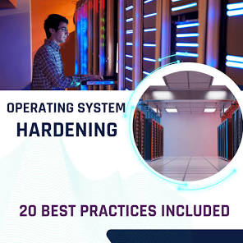
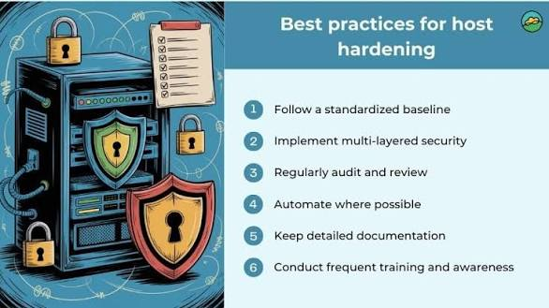
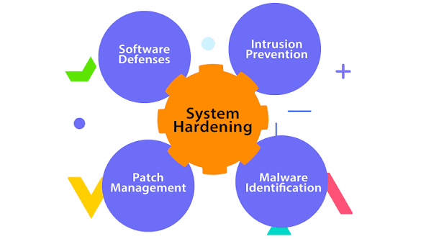
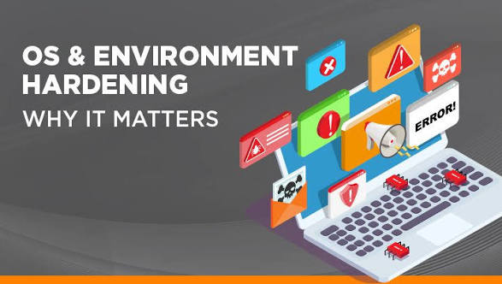
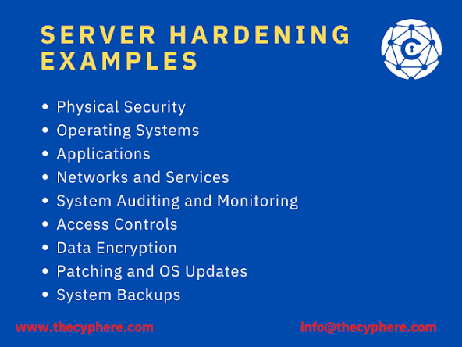
View all
OS hardening involves minimizing the attack surface by removing unneeded software/services, regularly patching, enforcing strong access controls (least privilege, MFA, strong passwords), configuring firewalls and encryption, enabling detailed logging, and monitoring for threats, using frameworks like SELinux/AppArmor and tools like Windows Defender to maintain a secure, minimal, and well-managed operating system environment.
Core Principles
- Principle of Least Privilege: Users and processes should only have the minimum permissions necessary to perform their functions.
- Minimize Attack Surface: Reduce potential entry points by removing unnecessary software, drivers, and services.
- Defense in Depth: Implement multiple layers of security controls.
Key Practices
- Patch & Update Management:
  - Automate applying OS and application security patches promptly.
  - Maintain supported OS versions.
- User & Access Control:
  - Disable default/guest accounts; strictly manage admin accounts.
  - Enforce strong, complex passwords, MFA, and account lockout policies.
  - Implement Role-Based Access Control (RBAC).
- Reduce Attack Surface:
  - Uninstall unused applications, drivers, and services.
  - Block unnecessary network ports.
  - Use application whitelisting.
- Network Security:
  - Configure host-based firewalls (e.g., Windows Firewall) with strict rules.
  - Deploy Intrusion Detection/Prevention Systems (IDS/IPS).
- Data Protection:
  - Encrypt sensitive data at rest (disk encryption like BitLocker/FileVault) and in transit.
  - Secure file system permissions.
- Logging & Monitoring:
  - Enable detailed logging of system events, errors, and warnings.
  - Store logs on remote, secure servers to prevent tampering.
  - Regularly audit configurations and scan for vulnerabilities.
- Secure Configuration:
  - Use security baselines or hardening frameworks (SELinux, AppArmor).
  - Harden default settings and secure remote access methods.
- Endpoint Protection:
  - Install and maintain anti-malware software.
  - Use endpoint detection and response (EDR) tools.

